Management Review

What is Management Review
# Source: AI Source: Provided by: [Data Path: Persons Table -> ID Column: 1, Name_En Column: Motasem Essam] -> From: [ChatGPT] on [8/23/2025]
A Management Review in software testing is a formal evaluation of the project’s progress, resources, and alignment with business goals, conducted by management rather than technical peers.
It’s not about finding bugs in code or test cases — it’s about making sure the project is on track in terms of scope, cost, schedule, risks, and compliance.

Key Points
# Source: AI Source: Provided by: [Data Path: Persons Table -> ID Column: 1, Name_En Column: Motasem Essam] -> From: [ChatGPT] on [8/23/2025]
- Objective:
To ensure that the work product (and the project itself) meets business, contractual, and regulatory requirements.
- Who is involved:
  - Project Manager / Test Manager
  - Senior Management / Stakeholders
  - Possibly QA Leads or Team Leads (to present reports)
  - Rarely the technical team in detail — focus is higher-level.
- When it happens:
At milestones or key phases (e.g., end of test planning, after a major release cycle).

What’s Reviewed
# Source: AI Source: Provided by: [Data Path: Persons Table -> ID Column: 1, Name_En Column: Motasem Essam] -> From: [ChatGPT] on [8/23/2025]
- Progress Reports → Are we on schedule?
- Budget and Resource Usage → Are we overspending?
- Quality Metrics → Defect trends, test coverage, pass/fail rates.
- Risk Management → Are there unresolved high-priority risks?
- Compliance → Are we following required standards (ISO, CMMI, FDA, HIPAA, etc.)?

Real-World Example in Testing
# Source: AI Source: Provided by: [Data Path: Persons Table -> ID Column: 1, Name_En Column: Motasem Essam] -> From: [ChatGPT] on [8/23/2025]
Scenario: Testing phase for an online banking system.
Artifacts Reviewed:
- Test execution summary (95% of planned tests executed, 5% blocked)
- Defect report (15 open critical defects, mostly in fund transfer module)
- Risk report (integration with payment gateway vendor delayed by 2 weeks)
- Budget usage (85% spent, 60% of testing done — risk of budget overrun)
Management Action:
- Approve additional budget for 2 more testers to speed up execution.
- Prioritize critical defect fixes before moving to UAT.
- Escalate vendor integration delay to contract team.

How It Differs from Other Reviews
# Source: AI Source: Provided by: [Data Path: Persons Table -> ID Column: 1, Name_En Column: Motasem Essam] -> From: [ChatGPT] on [8/23/2025]
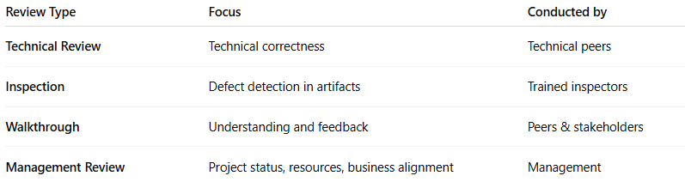
Review Type | Focus | Conducted by
Technical Review | Technical correctness | Technical peers
Inspection | Defect detection in artifacts | Trained inspectors
Walkthrough | Understanding and feedback | Peers & stakeholders
Management Review | Project status, resources, business alignment | Management

